QUESTIONNAIRE
Assistant of the Department of «Agronomy, Plant Breeding and Biotechnology»

Personal Information about teacherr
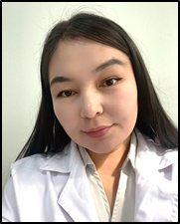 | Last name, first name, patronymic (according to personal documents): |  | Ularbek Dannar
 | Date of birth (day, month, year): |  | 18.08.1998г.
 | Gender (male/female): |  | Female
 | Nationality: |  | Kazakh
 | Citizenship: |  | Republic of Kazakhstan
 | Mobile phone, E-mail: |  | +77057243215  dannarularbek@mail.ru
Education
Higher Education Institution:
а) Name: |  | Kazakh National Agrarian Research University
б) Country, City: |  | Kazakhstan, Almaty
в) Years of study (admission – graduation): |  | 2017-2021 г.
г) Qualification awarded upon graduation: |  | 5B080100 – «Agronomist»
Place of Employment (current)
Full name of the organization: |  | Non-profit Joint Stock Company “Kazakh National Agrarian Research University”
Position held: |  | Laboratory assistant, Department of “Agronomy, Plant Breeding and Biotechnology”
Foreign Language Proficiency
Язык | Level (low, medium, high)
Language | Intermediate

